**Accuracy measures for Regression problem:**

**MAE,MSE,RMSE,r2_score,adjusted_r2_score,**

**ACCURACY MEASURES for Classification problem**

Confusion Matrix: TP,TN,FP,FN

Precision

Recall

F1 score

Accuracy

**How to evaluate the performance of a machine learning model?**

Let us consider a task to classify whether a person is **pregnant** or **not pregnant**. If the test for pregnancy is positive (+ve ), then the person is pregnant. On the other hand, if the test for pregnancy is negative (-ve) then the person is not pregnant.

Now consider the above classification ( pregnant or not pregnant ) carried out by a machine learning algorithm. The output of the machine learning algorithm can be mapped to one of the following categories.

In this we have 4 categories:

TP True Positive

TN True Negative

FP False Positive

FN False Negative

1. A person who is actually pregnant (positive) and classified as pregnant (positive). This is called **TRUE POSITIVE (*TP*).**

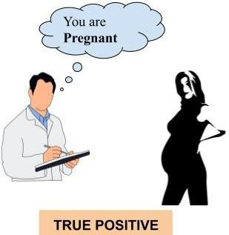

Figure : True Positive.

2. A person who is actually not pregnant (negative) and classified as not pregnant (negative). This is called **TRUE NEGATIVE (*TN*).**

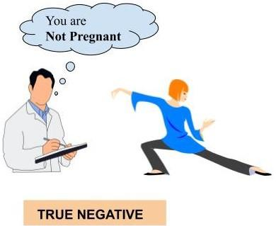

Figure : True Negative.

3. A person who is actually not pregnant (negative) and classified as pregnant (positive). This is called **FALSE POSITIVE (*FP*).**

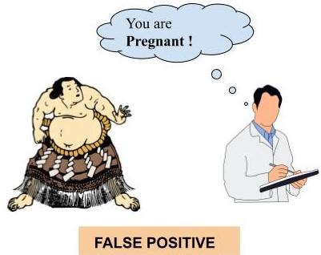

Figure : False Positive.

4. A person who is actually pregnant (positive) and classified as not pregnant (negative). This is called **FALSE NEGATIVE (*FN*).**

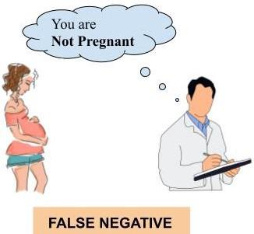

Figure . False Negative.

What we desire is **TRUE POSITIVE** and **TRUE NEGATIVE** but due to the misclassifications, we may also end up in **FALSE POSITIVE** and **FALSE NEGATIVE.**So there is a confusion in classifying whether a person is pregnant or not. This is because no machine learning algorithm is perfect. Soon we will describe this confusion in classifying the data in a matrix called confusion matrix.

Now, we select **100 people which** includes pregnant women, not pregnant women and men with fat belly.

Let us assume out of this 100 people 40 are pregnant and the remaining 60 people include not pregnant women and men with fat belly. We now use a machine learning algorithm to predict the outcome. The predicted outcome (pregnancy +ve or -ve) using a machine learning algorithm is termed as the ***predicted label*** and the true outcome (in this case which we know from doctor’s/expert’s record) is termed as the ***true label***.

Now we will introduce the ***confusion matrix*** which is required to compute the ***accuracy*** of the machine learning algorithm in classifying the data into its corresponding labels.



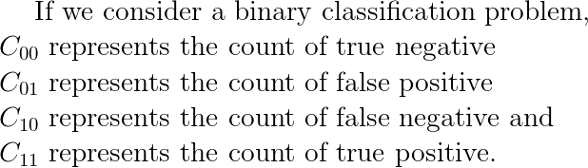

The following diagram illustrates the confusion matrix for a binary classification problem.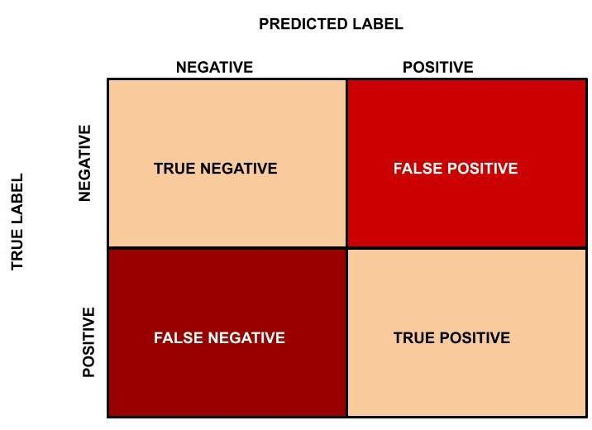

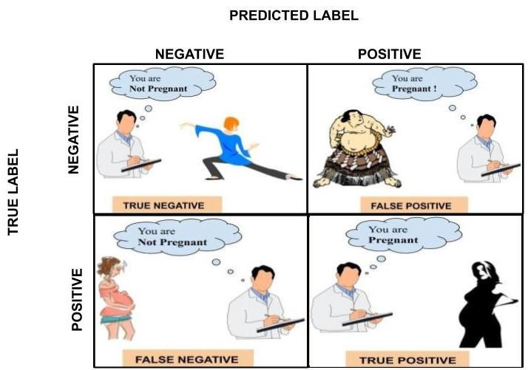

Figure : Confusion Matrix.

We will now go back to the earlier example of classifying 100 people (which includes 40 pregnant women and the remaining 60 are not pregnant women and men with a fat belly) as pregnant or not pregnant. Out of 40 pregnant women 30 pregnant women are classified correctly and the remaining 10 pregnant women are classified as not pregnant by the machine learning algorithm. On the other hand, out of 60 people in the not pregnant category, 55 are classified as not pregnant and the remaining 5 are classified as pregnant.

60: Not pregnant, 40: Pregnant

In this case, ***TN*** = 55,***FP*** = 5, ***FN*** = 10, ***TP*** = 30. The confusion matrix is as follows.

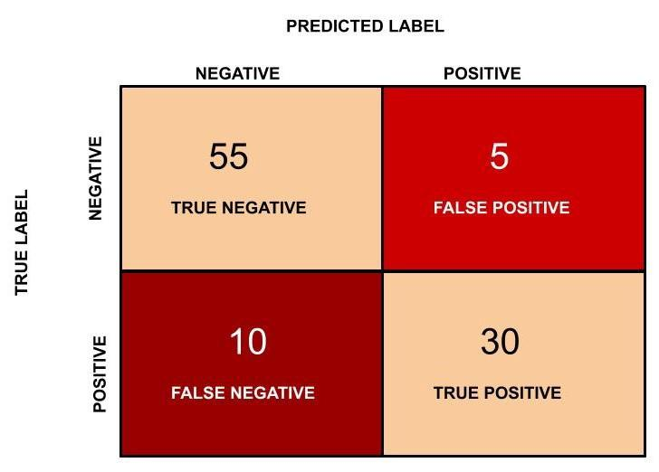

Figure: Confusion matrix for the pregnant vs not pregnant classification.

**What is the accuracy of the machine learning model for this classification task?**

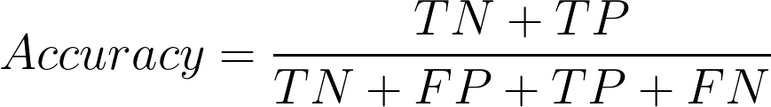

Accuracy represents the number of correctly classified data instances over the total number of data instances.

In this example, Accuracy = (55 + 30)/(55 + 5 + 30 + 10 ) = 0.85 and in percentage the accuracy will be 85%.

**Is accuracy the best measure?**

Accuracy may not be a good measure if the dataset is not balanced (both negative and positive classes have different number of data instances). We will explain this with an example.

Consider the following scenario: There are 90 people who are healthy (negative) and 10 people who have some disease (positive). Now let’s say our machine learning model perfectly classified the 90 people as healthy but it also classified the unhealthy people as healthy. What will happen in this scenario? Let us see the confusion matrix and find out the accuracy?

In this example, ***TN*** = 90, ***FP*** = 0, ***FN***= 10 and ***TP*** = 0. The confusion matrix is as follows.

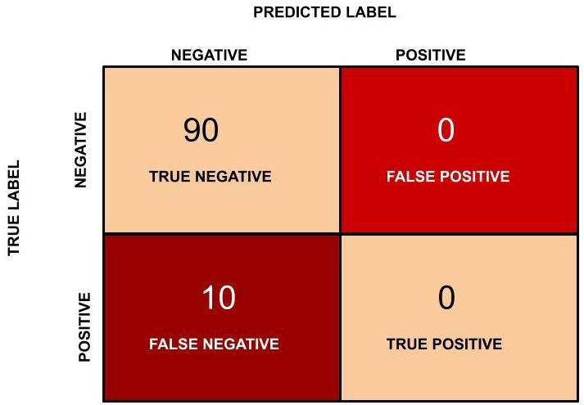

Figure : Confusion matrix for healthy vs unhealthy people classification task.

Accuracy in this case will be (90 + 0)/(100) = 0.9 and in percentage the accuracy is 90 %.

**Is there anything fishy?**

The accuracy, in this case, is 90 % but this model is very poor because all the 10 people who are unhealthy are classified as healthy. By this example what we are trying to say is that accuracy is not a good metric when the data set is unbalanced. Using accuracy in such scenarios can result in misleading interpretation of results.

So now we move further to find out another metric for classification. Again we go back to the pregnancy classification example.

Now we will find the **precision (positive predictive value)** in classifying the data instances. Precision is defined as follows:

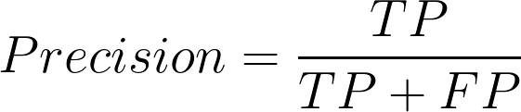

**What does precision mean?**

***Precision*** should ideally be 1 (high) for a good classifier. ***Precision*** becomes 1 only when the numerator and denominator are equal i.e ***TP = TP +FP***, this also means ***FP*** is zero. As ***FP*** increases the value of denominator becomes greater than the numerator and ***precision*** value decreases (which we don’t want).

So in the pregnancy example, ***precision*** = 30/(30+ 5) = 0.857

Now we will introduce another important metric called ***recall***. ***Recall*** is also known as ***sensitivity***or ***true positive rate*** and is defined as follows:

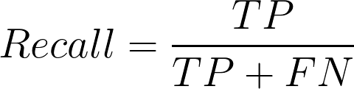

***Recall*** should ideally be 1 (high) for a good classifier. ***Recall*** becomes 1 only when the numerator and denominator are equal i.e ***TP = TP +FN***, this also means ***FN*** is zero. As ***FN*** increases the value of denominator becomes greater than the numerator and ***recall*** value decreases (which we don’t want).

So in the pregnancy example let us see what will be the recall.

***Recall***= 30/(30+ 10) = 0.75

Automotive Industry

Build a ML model to predict machine is working or not

Aim: to Increase Production without any stop

Working means +ve ,Not working means -ve

**FP: Machine is not working but model predicts Working (FP will impact on Precision)**

**FN: Machine is working ,but model predicts Not working (FN will impact on Recall)**

So ideally in a good classifier, we want both ***precision*** and ***recall*** to be one which also means ***FP*** and ***FN*** are zero. Therefore we need a metric that takes into account both ***precision*** and ***recall***.

***F1-score*** is a metric which takes into account both ***precision*** and ***recall*** and is defined as follows:

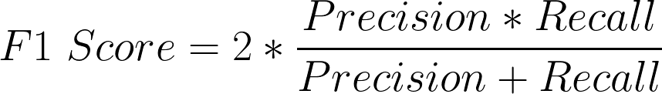

***F1 Score*** becomes 1 only when ***precision*** and ***recall***are both 1. ***F1 score***becomes high only when both ***precision*** and***recall*** are high. ***F1 score*** is the harmonic mean of ***precision*** and ***recall*** and is a better measure than ***accuracy***.

In the pregnancy example, ***F1 Score*** = 2* ( 0.857 * 0.75)/(0.857 + 0.75) = 0.799.

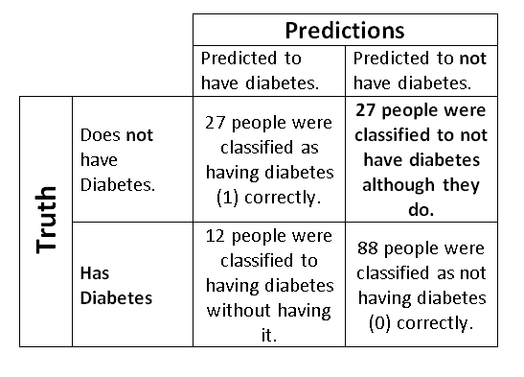

<https://towardsdatascience.com/performance-metrics-for-binary-classifier-in-simple-words-be958535db49>